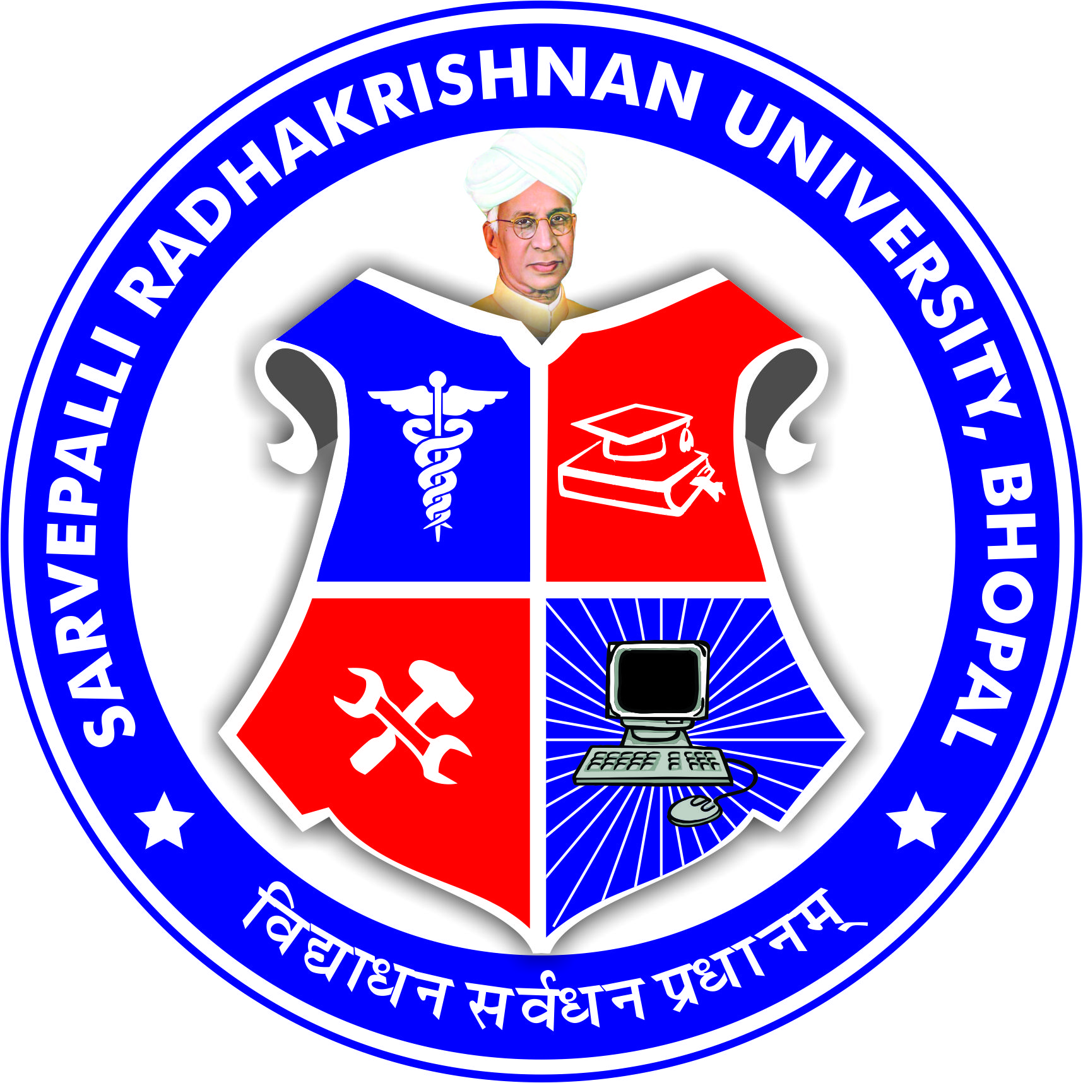
SARVEPALLI RADHAKRISHNAN UNIVERSITY
NH 12,RKDF IST CAMPUS, HOSHANGABAD ROAD, MISROD, BHOPAL (M.P.)
¼Statutory University established by Govt. of M.P. under section 2(F½ of UGC act)
Website: www.srku.edu.in, E-mail: info@srku.edu.in/srkubhopal@gmail.com
Phone: 0755-4700981 Fax: 07554700981

Academic Council
Order
As per the provision of statute No. 11 the Academic Council of Sarvepalli Radhakrishnan University is reconstituted as under: -

1 | Dr. Priyanka Jaiswal | Vice Chancellor | Chairman
2 | Dr. Ramdeen Tyagi | Ayog Nominee | Member
3 | Shri Ajay Kumar Jain | Ayog Nominee | Member
4 | Dr. Chinmay Bhatt | Dean IST | Member
5 | Dr. Shivanand B.B. | Dean Dental | Member
6 | Dr. Pratyush Jain | Dean Pharmacy | Member
7 | Dr. Devendra Dhote | Dean Homoeopathy | Member
8 | Dr. A. K. Shrivastav | Dean Medical | Member
9 | Dr. Bharti Chourasia | Professor | Member
10 | Dr. Archana Selvan | Professor | Member
11 | Dr. Rakesh Pandey | Professor | Member
12 | Dr. Sushil Singh | Professor | Member
13 | Dr. Varsha Namdeo | Professor | Member
12 | Dr. Namrata Jain | Professor Chancellor Nominee | Member
13 | Dr. Richa Gupta | Professor Chancellor Nominee | Member
14 | Dr.S.S. Pawar | Registrar | Member Secretary

Registrar

